Thank you for your interest in the Conversational English project. We will try to pair you with a volunteer tutor. Please fill out the application form and return it to volunteer@src.gla.ac.uk

Please note that volunteer tutors are not required to have any formal teaching qualifications. They are volunteers and will be students at Glasgow University from across a broad range of academic disciplines.

The tutors are volunteering to meet with international students, to chat with them in an informal environment and to help them improve their confidence and fluency in English. We usually suggest that you meet with your paired student around once a week, for an hour, at a mutually convenient time and place.

However, it is up to you and your partner to decide a routine which works best for you.
Please note that although we will try our best to find you a speaking partner, demand from students often outweighs the number of volunteer tutors available.

Please check your email regularly – if you decide not to go ahead with the project, please inform the SVSS Coordinator.

If you have any problems or questions once you have been allocated a tutor, please feel free to contact volunteer@src.gla.ac.uk

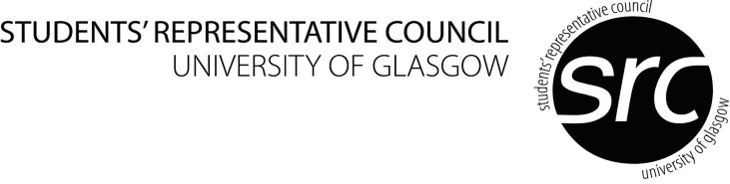
PLEASE RETURN TO:
SVSS COORDINATOR
JOHN McINTYRE BUILDING
UNIVERSITY AVENUE
GLASGOW
G12 8QQ

volunteer@src.gla.ac.uk

Conversational English - Application Form
(Students Requiring a Tutor)

Block Capitals please

PERSONAL DETAILS
Forename: |  |  |  | Surname:
Student Number: |  | Date of Birth: |  |  |  |  | Male/Female:
Student Email (please print clearly):
Home Address: |  |  |  |  | Term Address:
Postcode: |  |  |  |  | Postcode:
Home Tel: |  |  |  |  | Term Tel:
What country are you from?
When will you leave Scotland?

LANGUAGES
What languages do you speak?  Please also indicate level of fluency  Basic (B)  Intermediate (I)  Fluent (F) |  |  | Languages:
College (please tick) | Art |  |  |  |  | Medical, Veterinary & Life Sciences
 | Science & Engineering |  |  |  |  | Social Sciences
Undergraduate/Postgraduate (please circle) |  |  |  | Subject area of Study:
When will you return to your home country?

Do you consider yourself to have a disability? Yes No

Are there any special arrangements we can make for you? Yes No

If yes, please give details:

